#### Palletizing and Stretch Wrapping

|  |  |
| --- | --- |
| PPE and Lifting Safety | **PPE**  Wear leather or Kevlar gloves when:   * Handling wooden pallets * Attaching stretch wrap to pallets. * Handling cardboard * Moving drums or stacking drums   **Lifting**  Avoid lifting drums:   * Use vacuum hoist when possible   If a drum is lifted:   * Use two people * Use the proper lifting technique: Bend the legs and lift with the legs |

|  |  |
| --- | --- |
| Safety | **Do Not Touch Exception List**.   * Direct touching with low hazard potential: Stretch wrap machines. * Keep body away from stretch wrap machine when in operation. * Be aware of pinch points BEFORE working with stretch wrap machine. * Do Not Touch Exceptions are on the following pages: * Moving the pallet to the stretch wrapper – page 7 * Attach the film to the pallet – page 7 * Holding the slip sheet on top of the skid – page 7 * Applying the labels to the pallet – page 9 |

|  |  |
| --- | --- |
| Safety – Lock, Tag and Try | * "Lock, tag, and try" must be followed when changing film or when maintenance work is to be performed on stretch wrap machine. * The three stretch wrap machines in the lag area are approved for and installed with equipment safety locks. * In accordance with Environmental, Health and Safety Procedure 508, a person who is “locking-out” a piece of equipment in which he will be the ONLY ONE doing work can install a danger tag and an equipment safety lock to insure his personal safety. |

Continued on next page

Palletizing and Stretch Wrapping, Continued

|  |  |
| --- | --- |
| Drum Tip or Topple -> 2nd Quality | If a drum   * tips, tilts, or topples over * then disposition the drum to 2nd quality.   If at any time a drum was to “tilt” that could result in the powder flowing or moving, then disposition that drum to 2nd quality. Be especially mindful of this if manually moving drums.  Tilt, tip or toppling can result in damaged as shown below. |

Continued on next page

Palletizing and Stretch Wrapping, Continued

|  |  |
| --- | --- |
| **Overview: Assembling Drums on Pallet for Shipment** | After drums have been filled, lidded and labeled, they are:   * conveyed to the palletizing area where they are manually palletized using the lift table on each line, * stretch wrapped, * label and label cross checked and * moved to the warehouse. * P-009 Fine Powder Lag Operator Checklist completed by Lag Operator each shift.   Figure 1 is a basic diagram with packaging specification numbers. |

**Figure 1. 12 drums on pallet**

PL-30-10K

wooden pallet

60 liter plastic drums

PL-8-143

plastic sheet

stretch wrap

PL-3-189

corrugated sheet

PL-3-188

corrugated sheet

TEF

TEF

TEF

TEF

TEF

LON®

LON®

LON®

LON®

LON®

LON®

Continued on next page

Palletizing and Stretch Wrapping, Continued

|  |  |
| --- | --- |
| **Assembling Drums on Pallet** | 1. Retrieve a stack of the proper wooden pallets (PL-30-10K 42”x42”) from the warehouse and place 10 pallets **MAXIMUM** next to the lift table. 2. Place the pallet (PL-30-10K 42”x42”) on the lift table. If needed, use a metal hook to transfer the pallet from the stack to the lift table. 3. Place a corrugated sheet on the pallet (all products 1st and 2nd quality) 4. Place drums on pallet. Stack plastic drums three high.    * **Locking ring:** Place drums on the pallet with the sides of the locking rings touching the rings on adjacent drums. The locking rings must not be allowed to overlap.    * **Chimes:** Each drum should have a tamper resistant seal on the locking ring. 5. Place a plastic sheet on top of the drums. 6. Place a corrugated sheet on top of the plastic sheet.   The palletized material is now ready to be stretch wrapped.  Figures 2, 3 and 4 show example drum stacking. |

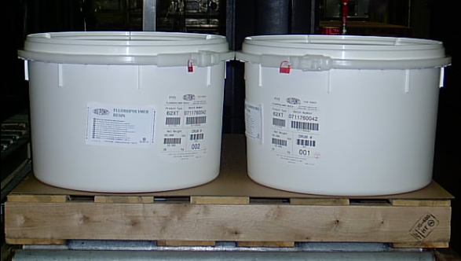

Figure 2. 1st Layer of Drums. Lock rings are not sticking out and are not touching or overlapping.

Continued on next page

Palletizing and Stretch Wrapping, Continued

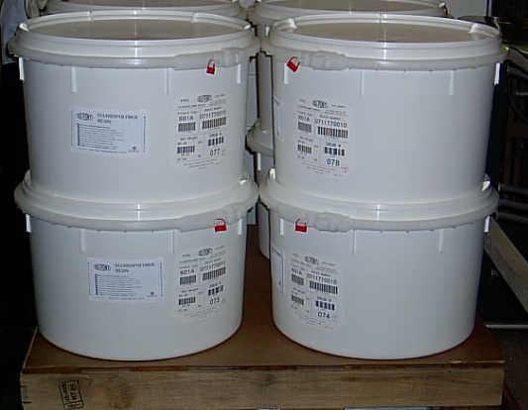

Figure 3. 1st and 2nd Layer of Drums. Lock rings, labels and chimes are aligned. no locking overlap, chimes and labels visible.

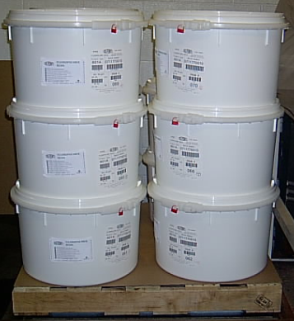

Figure 4. All Three Layers of Drums. Ready for stretch wrap.

Continued on next page

Palletizing and Stretch Wrapping, Continued

|  |  |
| --- | --- |
| **Partial Pallet Preparation** | **Partial Pallets:** See Figure 5 for proper positioning of drums for partial pallets. The positioning of drums on partial skids is extremely important to the integrity of the stretch wrapped skid. |

ONE DRUM ON A SKID

* Product labels face lock rings

TWO DRUMS ON A SKID

* Product labels face side of skid

THREE DRUMS ON A SKID

* Place drums close together

**Figure 5. Partial Pallet Preparation**

Continued on next page

Palletizing and Stretch Wrapping, Continued

|  |  |
| --- | --- |
| Stretch Wrapping the PalletDo Not Touch Exceptions  Do Not Touch Exceptions | **Do Not Touch Exception!**   * The following exception may be made for direct touching with low hazard potential. * Reason: Moving the pallet from the palletized station to the stretch wrapper turn table. The turn table will not be moving while pushing the pallet to the turn table.   **Moving the pallet to the stretch wrapper.**   * Ensure the stretch wrapper and turn table are not moving or set to move. * Push the palletized skid off the lift table onto the center of the turn table. * Center skid on the turn table. * Move the turn table rolls from “unlock” to the “lock” position to lock the rollers. This will keep the rollers from moving and not let the pallet roll off the table while stretch wrapping. * Move the lift truck away from the stretch wrap machine. * The stretch wrap machine is barricaded with a photo eye across the front of the turntable to interlock the system down if the photo eye beam is broken during operation.   **Do Not Touch Exception!**   * The following exception may be made for direct touching with low hazard potential. * Reason: Attaching the film to the pallet, and cutting the film when wrapping is complete. And placing a weight on top of the skid to hold down the slip sheet. Both action will be completed when the turntable and stretch wrapper is not moving.   **Attach the film to the pallet.**   * Gather film to form a "rope" and tie around the corner of the pallet. * Attach film to pallet on the side opposite of the film carriage.   **Holding the slip sheet on top of a skid.**   * During rotation of the turn table the slip sheet will move. * A couple pound weight can be placed on top of the slip sheet to keep it in place. After the pallet is wrapped the weight will then be removed and located at the lag operator station. * Adjust the height stop according to size of drums and number of drums being wrapped. Markers are provided to indicate where the stop should be set. |

Continued on next page

Palletizing and Stretch Wrapping, Continued

|  |  |
| --- | --- |
| Stretch Wrapping the Pallet (Continued) | * Dial in the number of wraps for the top and bottom. The number of wraps are: * **Top = 3** * **Bottom = 6** * Push STOP/RESET button. The yellow ready light will come on indicating that the machine is ready. * Set the tension between 60 and 70. * The more tension, the tighter the wrap. * Maintain tension as close to 70 as possible. * Do not to make the wrap too tight. This can cause the drum lock rings overlap one another. * Push START button. The machine will begin its cycle: * The film will be applied to the pallet starting at the bottom. * The machine will wrap a single layer of film at the bottom and then start spiraling up. * When the carriage reaches the height stop, the machine will wrap the preset number of times. * The stretch wrap machine will spiral down to the bottom and wrap the preset amount of times there. * It may be necessary to jog the stretch wrap machine if an extra wrap is needed in the area just above the pallet. * After the stretch wrap machine has completed its cycle,   cut the film about half way between the load and the film roller.   * Tuck the tail of the film under the stretched film on the pallet. |

Continued on next page

Palletizing and Stretch Wrapping, Continued

|  |  |
| --- | --- |
| Label the Stretch Wrapped PalletDo Not Touch Exception | **Do Not Touch Exception!**   * The following exception may be made for direct touching with low hazard potential. * Reason: Labeling the pallet with packaging labels while on the stretch wrap turn table.   **Attaching labels to the wrapped pallet and drums.**   * Ensure the machine is not moving when performing this action. * When placing the labels stand facing the pallet side.  1. Place a **"CAUTION - HANDLE GENTLY"** label on right front side of each drum pallet. 2. Hold the pallet label next to the drum label and **cross check**. 3. Use four pallet labels to place a **pallet label on each side** of the skid. 4. **Inspect skid** after wrapping. Check that:    * the package is properly secured and neat,    * no locking rings are overlapping (example on page 9), and    * there are no holes in the film wrap to allow dirt to be drawn in.    * none of the locking rings on the drums are overlapping the rings on adjacent drums.    * chimes are in place 5. **Scan pallet** into SAP using the correct process order. (You can obtain process order from scheduling board in B-162 upstairs hallway.) 6. **Move the pallet** to the Warehouse. Place the skid in the proper row and space it approximately 4 inches from other skids using the guidelines painted in the rows, as shown in figure 6. 7. Once the pallet is in the warehouse unlock the turn table rollers. This will set the stretch wrapper ready for the next pallet.     **Figure 6. An example of skids spaced apart** |

Continued on next page

Palletizing and Stretch Wrapping, Continued

|  |  |
| --- | --- |
| Label the Stretch Wrapped Pallet -(Continued) | 1. Lower pallets slowly- quick drops can cause compact powder. 2. Every lockband should be attached to the drums. Figure 7 shows incorrect and correct lid assembly.     **Figure 7. The lid on the left is not attached correctly, the lid on the right is attached correctly.**   1. Do not transport pallets double stacked. |

**Figure 8 below shows an example of drum overlapping.**

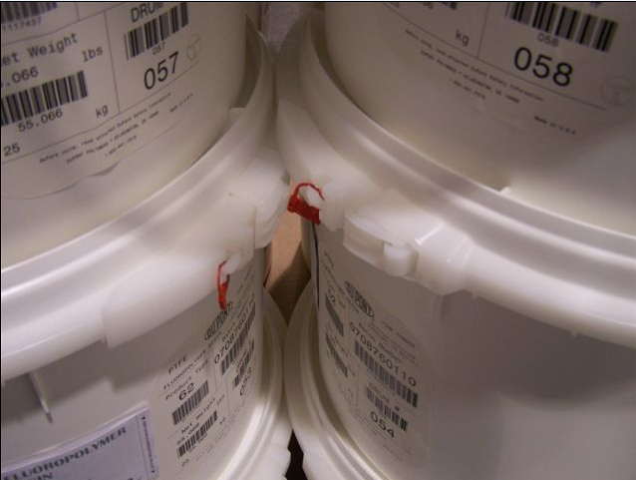

Figure 8. An example of Locking Ring Latches that are overlapping. This is unacceptable.

End of Topic

#### Stretch Wrap Machine

|  |  |
| --- | --- |
| Changing Stretch Wrapping Film | * Lock Out, Tag, and Try (see Washington Works Safety & Health Manual Procedure 508) stretch wrap machine prior to changing film. * Swing stretch roller assembly away from the roll post. * Remove the empty film roll core. * Place a roll of 20” film on the roll post so roll turns **CLOCKWISE** as the film unwinds. * Unroll about five feet of film and thread it behind the small pinch roller. * Then thread it in front of the first stretch roller. * Finally, thread it behind the check switch and behind the idler roller. * Pull the film to swing the roller assembly against the film roll. The film should lie flat against the roll and all rollers with no sag or double back. |

|  |  |
| --- | --- |
| LINE 1 LANTECH Stretch Wrapping Machine: Loading Film | * Push the emergency Stop button on the operator control panel. * Lock Tag and Try the machine. * Place a roll of stretch film on the film post. * Open the thread roll carriage gate by releasing the latch and pulling the gate handle. * Thread the film as indicated on the Film Threading Diagram (decal on the top of roll carriage) and close thread gate.   **NOTE:** When closing the EZ Thread gate do not pull the film tight. Allowing some slack in the film will make it easier to close the gate and reduce the chance for film breaks at start-up.   * Verify the thread gate is closed and latched. * Unlock the machine. * Turn on the main disconnect. * Pullout the Emergency Stop button on the operator control panel. |

Continued on next page

Stretch Wrap Machine, Continued

|  |  |
| --- | --- |
| LINE 1 LANTECH Stretch Wrapping Machine | **Machine Operation:**   * Place load in the center of the wrapping turntable. * Press FILM ASSIST button on the operator control panel and pull film to the product load. * Attach the film between the lower tiers of the load or between the load and the pallet. * Press the START button. * Once the load is wrapped, ensure the film is cut and tuck the tail of film on the side of the load. * Remove the utilized load.   **Shutdown Options:**   * Emergency Shutdown – Press the Emergency Stop button on the operator control panel.   During wrap cycle – Press the Emergency Stop or the Cycle Pause button. |

|  |  |
| --- | --- |
| Trouble-Shooting | This section provides trouble shooting for common problems with the Lantech Q series stretch wrapper. |

|  |  |
| --- | --- |
| Excessive film breaks | * The *Wrapping Force* control is set too high. * The film roll has damage or abuse. Any holes, frayed edges or cuts on the surface or end of the roll may cause film delivery problems. * Improper film threading. Refer to the diagram on the top of the roll carriage. * There is excessive film residue built up on the prestretch rollers. Clean rollers with ammonia or detergent based household cleaner. * The load has sharp corners or objects that may be puncturing the film web. * The *Preset P2* value, Reduced Wrapping Force Off Delay, is programmed too low (less than 3 seconds). |
| Machine does not power up | * The electrical cord is not plugged into an operating outlet. * The *Emergency Stop* button is pulled out. * The *Cycle Pause* mode is activated. If this LED is illuminated, press *Cycle Pause* push button again to resume machine cycle. |

Continued on next page

Stretch Wrap Machine, Continued

|  |  |
| --- | --- |
| Turntable will not rotate when JOGGED / difficulty starting | * The load weight exceeds turntable maximum weight capacity. * Foreign objects or materials restricting movement – inspect turntable area. * The *Turntable Speed* knob is turned to slow speed. |
| Turntable not position properly for unloading | * Turntable not at home position when loaded. The previous wrap cycle may have been interrupted. To solve this problem, always-rotate turntable to the home position when cycle is interrupted. * Turn table home proximity switch out of adjustment. |
| Large quantity of film applied to load/ machine did not shut off | * *Roll Carriage Speed* knob set to SLOW. * Top/Bottom Wrap Count set too high * Bottom limit switch is not being activated. |
| Roll carriage will not raise | * The *Roll Carriage Speed* control knob is turned to SLOW. * Foreign objects or material restricting movement. |
| Roll carriage does not raise while wrapping | * The lens of the *Load Height Sensing* photocell (PC-7) is dirty (located on the film roll carriage). * The *Load Height Sensing* photocell is out of alignment. PC-7 should be aimed to the center of the wrap zone. * Raise *Roll Carriage Delay Preset P3*, value is set too high. (Factory setting is 3.0 seconds) |
| Machine will not wrap to the top of the load | * *Load Height Sensing* photocell does not detect the product, due to possible gaps and hard sense areas of the load. * Eliminate gaps in the load stacking pattern for reflective, hard to sense areas. |
| Film is not being applied to the desired height above top of load | * *Film* *Carriage At Top Of Load Preset P1*, is not set for the correct amount of time.(Factory setting is 1.5 seconds) * The *Load Height Sensing* photocell PC-7 is seeing a light colored object in background above the height of the load. * The lens of the *Load Height Sensing* photocell is dirty. The *Load Height Sensing* photocell is out of alignment. |
| Roll carriage will not lower | * The *Roll Carriage Down* limit switch is stuck. (The switch is located inside the upright near the bottom) * *Roll Carriage Slack Belt* limit switch is not operating correctly. (The switch is located inside the top of the upright. The switch must be activated in order to lower the roll carriage.) |

Continued on next page

Stretch Wrap Machine, Continued

|  |  |
| --- | --- |
| Roll carriage does not lower to bottom position | * There are foreign objects or materials restricting movement * The *Roll Carriage Down* limit switch is out of adjustment |
| Film winds around prestretch rollers | * There is tack build up on the prestretch rollers * Film roller is damaged |
| Delivery system does not dispense film | * The *Preset P2* value, Reduced Wrapping Force Off Delay is programmed too low (less than 2.0 seconds) * The *Wrap Force* control is set too high. |
| Adverse wrap conditions caused by mis-adjustment of the Wrap Force Knob | * The corners of the loads are crushed. * The load is wrapped too tightly * The load is being pulled form the wrap zone/turntable * The load is not wrapped tight enough. |
| Auto film cut-off option is not working properly | * The electrical quick-disconnect is loose or disconnected. * Check for proper alignment of the unit |

End of Topic

#### Vacuum Hoist

|  |  |
| --- | --- |
| VACU-HOIST Procedure Steps | The Vacu-Hoist improves the ergonomics of the tour. Operators are required to move 55.1 lb. and 60 lb. drums, approximately 5 yards, from the conveyors to the second quality pallet area. The conveyor elevation is 3.5 feet high. Operators are carrying the drum to ground level. The Vacu Hoist will allow one employee to move the drums to the proper location.   * When second quality drum needs to be moved, turn the field switch to the Vacu Hoist Pump to the ON position. This should activate the vacuum to the hoist. Be aware the orange lift tube will retract up. * Position lift tube directly over load. (Lifting from any angle is not recommended.)      * Depress the control lever. The lift tube will extend lowering the suction head onto the drum lid.      * Establish firm contact with the load; raise control lever gradually to lift the load.      * When moving the drum let the hoist do the work. The hoist will maintain a vacuum on the drum, while the operator is free to move the drum with the handles on the suction head to its destination. * Keep the drum at arms’ length at all times. This is to insure the operator is safe, if for some reason the vacuum should release.      * Move toward the pallet area, pulling the drum behind. * Once over the pallet, release the vacuum control lever slightly. Once airflow can be heard through the suction head, the vacuum has been broken.   **CAUTION: When lowering a load, the vacuum control lever should be depressed SLOWLY, so as to decrease the possibility of releasing the load prematurely.**   * When the drum reaches the pallet or is set in place, continue to depress the control lever fully, and lift up on the suction head to break the seal. The orange lift tube should then recoil.      * The hoist is ready for the next drum or can be placed back into its storage spot and the pump turned off. * The pump should remain off at all times when the Vacu Hoist is not in use. * Lockout for the Vacu Hoist is at the field switch and in ECR 5. * There are two adjustment knobs on the suction head. The small silver knob should be closed. The black knob in the middle of the head adjusts the vacuum pressure on the tube. It should be left at the desired setting. |

Continued on next page

Vacuum Hoist, Continued

|  |  |
| --- | --- |
| Trouble-Shooting | This section provides trouble shooting for common problems with the vacuum hoist. |

|  |  |  |
| --- | --- | --- |
| PROBLEMS | **CAUSE** | **THINGS TO CHECK OR TRY** |
| Will not lift or lifts slowly | Blocked air flow or vacuum leak. | * Clear filter.   Eliminate leaks by:   * Tightening foot. * Check valve on filter. * Checking hoses for leaks ( on hose and at connections) * Check integrity of gasket. * Tightening limit screw into head. * Checking suction head and top swivel valves for blockage. * Checking gasket on canister. |
| Will not balance | Improper valve aperture or closure ratio. | * Adjust black knob with load-to-balance load. Release load and adjust silver no-load screw for no-load balance. If these first two things fail to balance in the load position, check for jamming of valves by foreign matter. * Check tension on three springs on bottom valve plate in suction head. Tighten nuts if springs seem weak. |
| Black handle loose | Side bolts (1/4” Allen) loose or bottom bolt loose or missing. | * Check bolts and tighten or replace as needed. |
| Frozen black load adjustment knob | Cover mis-aligned or black shaft mis-threaded. | * Loose four Phillips heads. |
| Black throttle extremely loose | Main spring is of inside head. | * Remove suction head and re-attach main spring. |
| Lift tube collapse | Suction foot sits on floor on off position or foot placed on immovable object while extended. | * New tube should be cut to allow 4-6 “ of neutral height above floor. |
| Jammed pump/burned out motor | Particulate by passing filter due to improper cleaning or pump may be jammed by contents of a broken bag or may be jammed by portions of a broken bag. | * Pump/motor replacement required. |
| Breaks or cuts in lift tube | Breakdown immediately above suction head or below swivel indicated improper overhead system or improper usage. | * Short term repairs: Duct tape * Sever cuts may require a new tube. * Overhead system may be too heavy. |

Continued on next page

Vacuum Hoist, Continued

|  |  |
| --- | --- |
| VACU HOIST Troubleshooting (Continued) |  |

|  |  |  |  |
| --- | --- | --- | --- |
| PROBLEMS | | **CAUSE** | **THINGS TO CHECK OR TRY** |
| Lift tube drops away from top swivel | Tape adhesive dried out to insufficient clamping at top swivel. | | * Re-tape, taping gasket directly to metal, then taping lift tube to gasket, add additional hose clamp, tape this and refit gasket over taped clamps. |
| Unit flutter or vibrates in neutral no-load state | Balancing valve is loose. | | * Tighten bolts holding springs. |
| Pump not producing sufficient vacuum | Gas shock may be leaking. | | * May need to replace gas shock (Part #80121). Check vacuum level first at pump intake port. |
| Product being lifted drops | Insufficient vacuum at foot to improper unit. | | * Check and clean filter. |

End of topic

**ADDENDUM #1**

**Changing Stretch Film on Line #1**

***Review Lock Out, Tag, and Try Washington Works Environmental, Health & Safety Procedure 508 prior to any lock out!***

**Step #1: Locking out the wrapper –**

* Use equipment lock at #1 stretch wrapper, danger tag, and red tongs.
* Push emergency stop button.
* Go to right hand breaker box on wall across from Line #2.
* Flip breaker #38 to off position and place red tongs on metal lock ring.
* Remember to follow the standard procedure to turn off the disconnect.
  + Stand to the side.
  + Look away from the disconnect switch when switching.
* Place completed danger tag on lock and place lock on tongs.
* Place key to lock in pocket until task is completed.
* Try to operate machine and make sure power is OFF!!

**Step #2: Changing film –**

* With machine locked out and key in pocket, open door to tension rollers, remove wrapping from rollers and remove old wrap roll from post.
* Place new wrap on machine as shown and carefully feed around rollers.
* Close door to tension rollers.

**Step #3: Unlocking wrapper –**

* Unlock lock and remove from tongs.
* Remove tongs from lock ring and flip breaker back on.
* Erase tag.
* Reset emergency stop and operate wrapper.

**REFERENCE ODs –**

33F5A1 – Fine Powder Products/Packaging Materials

33F5A3 – Palletizing and Stretch Wrapping

33F5A4 - Labeling

33F5A5 – Packaging

33F5J – FPPO ACSIS Guide

This addendum is located on Line 1 Stretch Wrapper, replace during review.

**ADDENDUM #2**

**Changing Stretch Film on Line #2**

***Review Lock Out, Tag, and Try Washington Works Environmental, Health & Safety Procedure 508 prior to any lock out!***

**Step #1: Locking out the wrapper –**

* Use equipment lock at #1 stretch wrapper, danger tag, and red tongs.
* Push emergency stop button.
* Flip field switch located on outside of wrapper down to the off position and place red tongs in hole above switch to prevent being flipped on.
* Remember to follow the standard procedure to turn off the disconnect.
  + Stand to the side.
  + Look away from the disconnect switch when switching.
* Place completed danger tag on lock and place lock on tongs.
* Place key to lock in pocket until task is completed.
* Try to operate machine and make sure power is OFF!!

**Step #2: Changing film –**

* With machine locked out and key in pocket, open door to tension rollers and remove old wrap.
* Place new wrap on machine as shown in diagram and carefully feed around rollers.
* Close door to tension rollers.

**Step #3: Unlocking wrapper –**

* Unlock lock and remove from tongs.
* Remove tongs from field switch and flip switch back up to on.
* Erase tag.
* Reset emergency stop and operate wrapper.

**REFERENCE ODs –**

* 33F5A1 – Fine Powder Products/Packaging Materials
* 33F5A3 – Palletizing and Stretch Wrapping
* 33F5A4 - Labeling
* 33F5A5 – Packaging
* 33F5J – FPPO ACSIS Guide

This addendum is located on Line 2 Stretch Wrapper, replace during review.

**ADDENDUM #3**

**Changing Stretch Film on Line #3**

***Review Lock Out, Tag, and Try Washington Works Environmental, Health & Safety Procedure 508 prior to any lock out!***

**Step #1: Locking out the wrapper –**

* Use equipment lock at #1 stretch wrapper, danger tag, and red tongs.
* Push emergency stop button.
* Flip field switch located on backside of wrapper to off position, and place red tongs in hole on switch to prevent being flipped on.
* Remember to follow the standard procedure to turn off the disconnect.
  + Stand to the side.
  + Look away from the disconnect switch when switching.
* Place completed danger tag on lock and place lock on tongs.
* Place key to lock in pocket until task is completed.
* Try to operate machine and make sure power is OFF!!

**Step #2: Changing film –**

* With machine locked out and key in pocket, open roll assembly, remove wrap and remove old wrap roll from post.
* Place new wrap on machine as shown on diagram, close roll assembly, and carefully feed around rollers.

**Step #3: Unlocking wrapper –**

* Unlock lock and remove from tongs.
* Remove tongs from field switch and flip switch back up to on.
* Erase tag.
* Reset emergency stop and operate wrapper.

**REFERENCE ODs –** 33F5A1 – Fine Powder Products/Packaging Materials

33F5A3 – Palletizing and Stretch Wrapping

33F5A4 - Labeling

33F5A5 – Packaging

33F5J – FPPO ACSIS Guide

This addendum is located on Line 3 Stretch Wrapper, replace during review.